EGN 4060C Final Project Report
Louis Deal
Miguel Grisales
Jesus Vargas
EGN 4060C
Professor Apan Dastider
12/7/2023

Abstract:
The goal of this project was to create a biomimetic robot which simulates the complex motion of a worm utilizing a flexible compliant mechanism. This project was selected as worm locomotion is a non-standard form of movement and far removed from bipedal movement, making it inherently more challenging and less intuitive to model with a robot.This mechanism consists of 2 servos, 3 3d-printed bodies, an Arduino Pro Mini microcontroller, a 9V battery, a voltage regulator, and a TCS34725.

The group accomplished a simulation of worm locomotion. This is done via constricting opposing wires routed through each of the 2 servos. These wires lift opposite ends of the worm’s body, releasing them at staggered times thus achieving forward motion.

Introduction:
Human kinematics are intuitive, it has been well documented that our rigid bones and flexible joints are easily modeled as linkage systems. Humanoid robotics ubiquitously replicate our rigid mechanisms and frequently replicate our compliant features. Our bones, the linkages; our joints, the robotic joints; our tendons, the spring shock-absorbers. Systems that do not operate on any of those principles seem alien to the human mind. Moreso to the engineer who mainly operates with the three kinds of design features listed above. With this project we will be approaching a form of movement that is seldom explored in kinematics. A worm does not have rigid linkages, no joints to speak of. Of the three items mentioned above it is primarily like a spring, an activatable muscle. Seldom do robots use springs alone as the method to achieve locomotion and we may attempt to find the reason why using this project. Our speed is of greatest concern. Worms do not have a great reputation for being agile or fast. We will see if that is a feature of their particular style of locomotion, or if it can be replicated while avoiding the shortfalls that typically lead to the worm traveling at an arduous worm’s-pace. An RGB sensor was used as a simple and easy to implement means of collecting environmental data. Tracking or seeking a specific color is a method by which we can say our robot behaves autonomously.

Method:
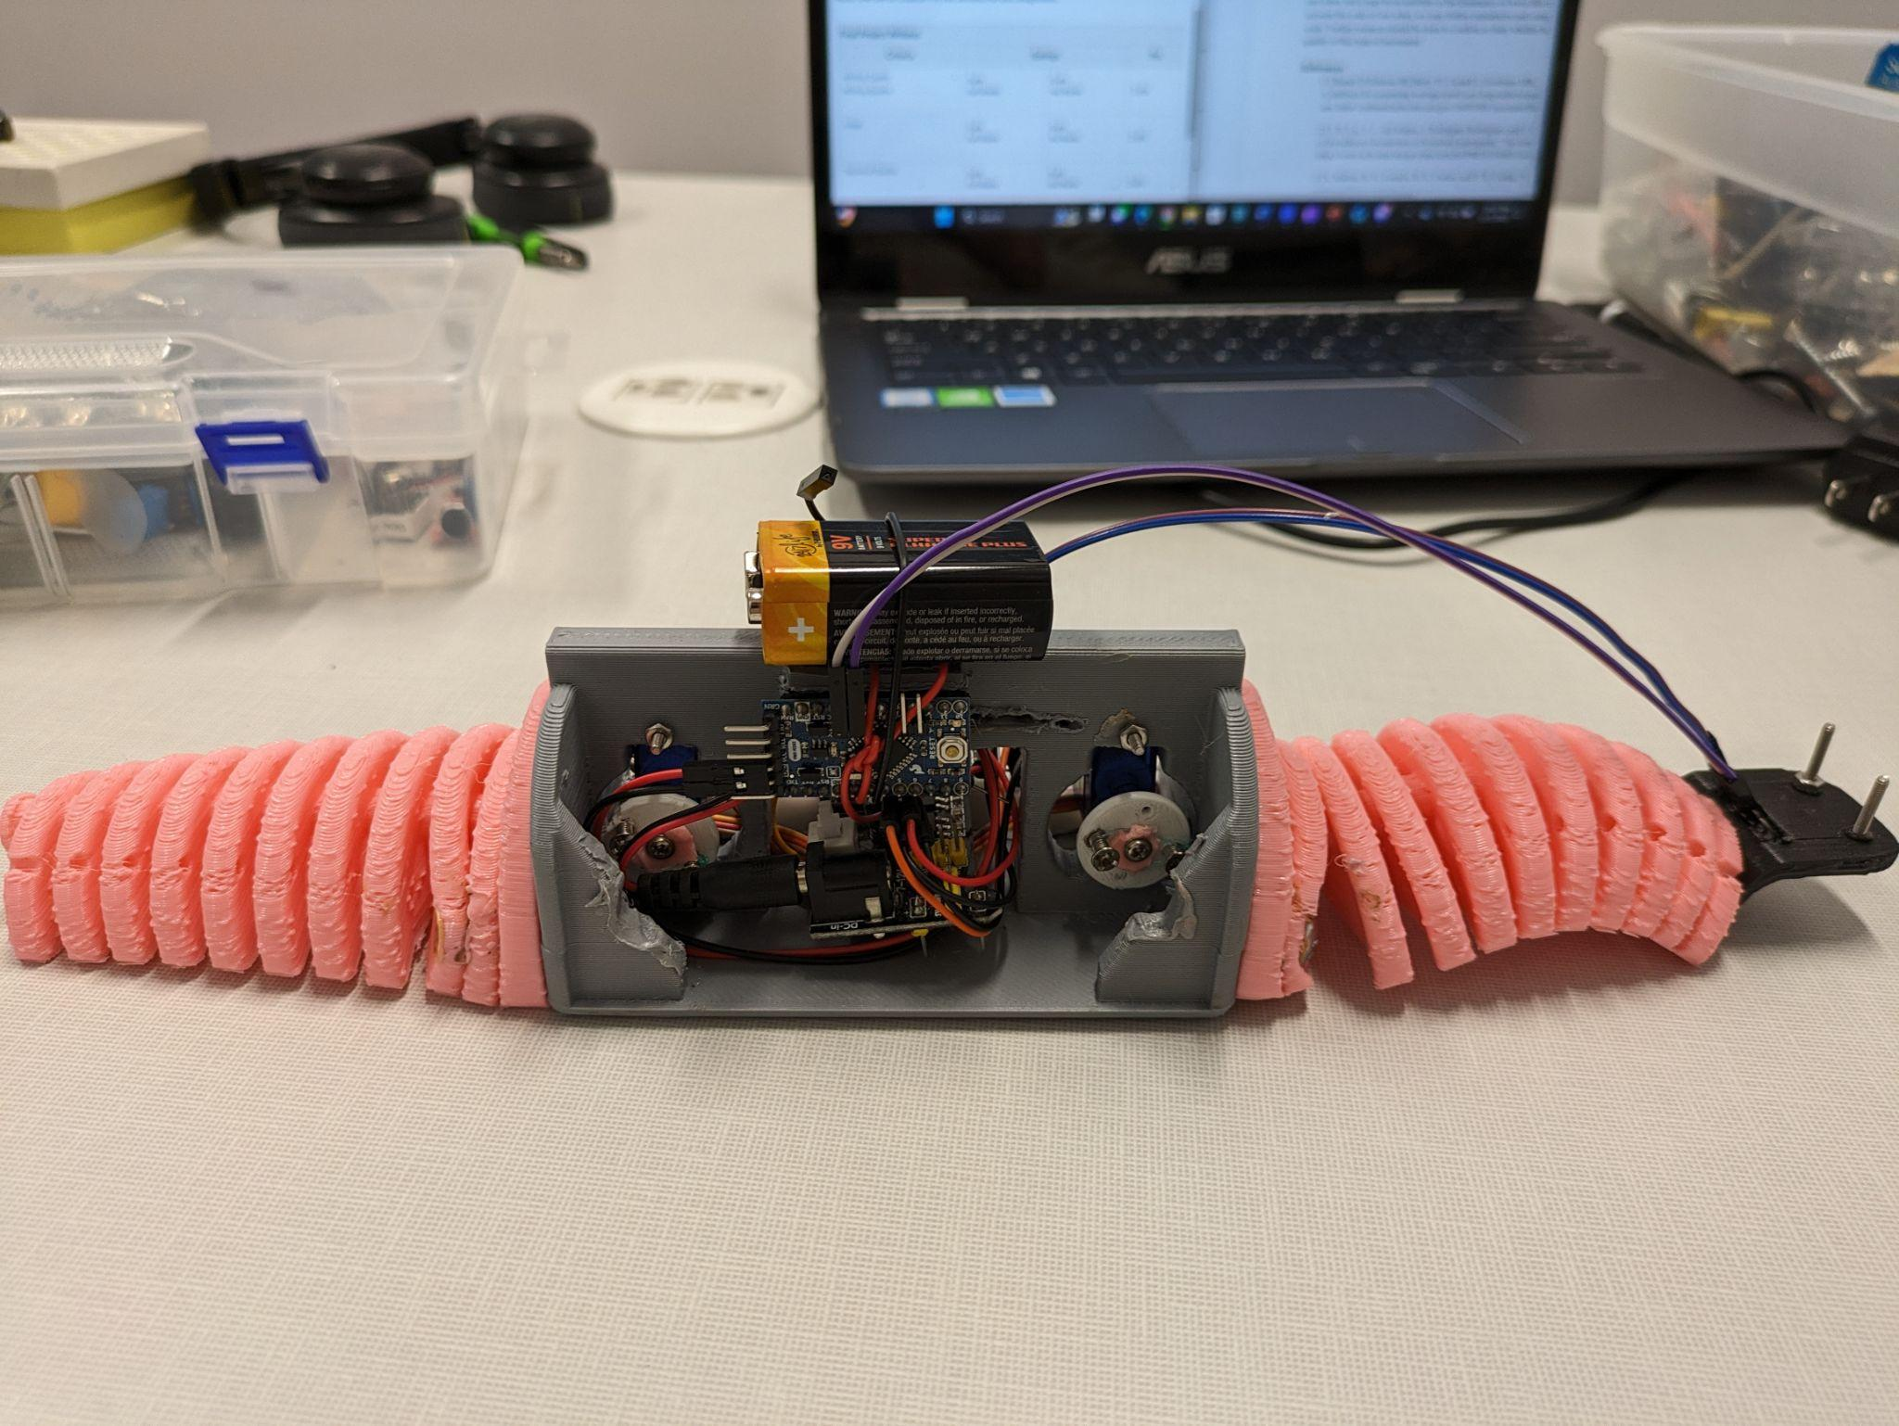
Figure 1: Side view of worm robot

The main and most important aspect of the project is movement. 2 servos contract nylon wire routed through a 3d-printed body, pulling the body in towards the center and turning the ends of the body towards the ground. Then, the 2 sides of the worm are released at staggered times, with the back releasing first and the front releasing afterwards. What results is the back of the worm pushing the front forward, achieving forward motion.

The microcontroller used on this project is the Arduino Pro Mini. As this MCU (Microcontroller Unit) lacks easily-accessed programming pins, it was programmed by tethering it to another MCU, an Arduino Uno, which was connected directly to a laptop running the Arduino IDE. Through lots of trial-and-error testing first with the TCS34725 RGB Sensor and later with the 2 SG90 servos, working code was achieved. Of course, this initial version of the code was functional in that it did not cause compilation errors within the IDE, but when implemented onto the assembled robot it did not achieve the desired result. The delays present in the code had to be completely reworked, ensuring that the series of contractions and releases occurs with such time as to ensure that it properly mimics a worm.

As it is currently configured, the robot will begin the process of contracting and releasing tension in the nylon wire as the RGB sensor detects a dominant presence of red. The TCS34725 sensor outputs 4 values, one for red, green, blue, and clear. Thus, by passing the collected red, green, and blue values into a function using a conditional statement to determine the dominance of red, one can effectively tell the robot to move when it sees red. This can be changed simply by changing which color the function searches for in the main loop, but real-time user input was not included in this project.

Below is the full code as it was written in the Arduino IDE:

#include <Wire.h>
#include <Adafruit_TCS34725.h>
#include <Servo.h>

// Create an instance of the TCS34725 sensor
Adafruit_TCS34725 tcs = Adafruit_TCS34725(TCS34725_INTEGRATIONTIME_50MS, TCS34725_GAIN_4X);

//Define servos
Servo servoh1;
Servo servoh2;
Servo servov;

//setup function
void setup() {
//set baud rate to 9600 (default rate for most serial terminals)
Serial.begin(9600);

// Check if the sensor is connected and initialized
if (!tcs.begin()) {
Serial.println("Couldn't find TCS34725, check connections and restart.");
while (1);
}

Serial.println("Color sensor initialized!");

//attach servos 1 2 and 3 to pins 4, 5, 7 on the Arduino Pro Mini
servoh1.attach(4);
servoh2.attach(5);
servov.attach(7);

// Initialize servo positions (resets worm legs)
servoh1.writeMicroseconds(1000);
servoh2.writeMicroseconds(1000);
servov.writeMicroseconds(1000);
}

//contract servos to lift the center body of the worm
void contractVertical(Servo &servo1, Servo &servo2) {
// Contract first servo
for (int i = 1000; i <= 4000; i += 20) {
servo1.writeMicroseconds(i); // Change servo rotation with changing i values, ending at 4000
delay(15); // Add a small delay for servo movement
}

delay(100); // Delay between the 2 servos contracting

// Contract second servo after delay
for (int i = 1000; i <= 4000; i += 20) {
servo2.writeMicroseconds(i); // Change servo rotation with changing i values, ending at 4000
delay(15); // Add a small delay for servo movement
}
}

// Function to return servo rotation to initial value of 1000
void releaseVertical(Servo &servo1) {

// Return servo rotation to initial value of 1000 with changing values of i.
for (int i = 1000; i <= 4000; i += 20) {
servo1.writeMicroseconds(4000 - i);
}
}

// Contract and release the servo when the red value from the sensor is dominant
void moveFwdRed(uint16_t r, uint16_t g, uint16_t b) {
if (r > g && r > b) {
// If red is dominant, contract and release servos
//contract
contractVertical(servoh1, servoh2);
//release back servo first
releaseVertical(servoh2);
delay(100);
//release front servo second
releaseVertical(servoh1);
}
}

//main loop
void loop() {
// Read color data
uint16_t r, g, b, c;
tcs.getRawData(&r, &g, &b, &c);

// Print the color values to the Serial Monitor
Serial.print("Red: "); Serial.print(r);
Serial.print(" Green: "); Serial.print(g);
Serial.print(" Blue: "); Serial.print(b);
Serial.print(" Clear: "); Serial.println(c);

// Control the servo based on color data
if (r > b) {
moveFwdRed(r, g, b);

delay(600); // Adjust the delay as needed
}

On the mechanical side of movement, friction and weight displacement play a key role in achieving controlled wave-like movement. The force of friction against the ground is the cause of forward movement, so a material that would have a high enough coefficient of friction was selected to grip the suffice while pushing itself forward. However, in order to prevent the other side of the robot from pushing it back the majority of weight of the robot must be placed within the center rigid chassis. Doing this means that no single compression or release motion on one single end will be enough to move the entire device forward

After the rear end is fully contracted each end simultaneously reverses its current state. The contracted end decompresses and the relaxed end compresses. Doing this simultaneously creates a pulling force on one end and a pushing force on the other.

The wires are oriented underneath where each of the flexible scales meet, this allows the contraction to create a moment at the location where the flexible arm interfaces the chassis. This torque will allow for a higher percentage of the weight of the robot to be felt at a single end. If the timing is right, the higher friction will be generated on the rear end allowing the rest of the robot to move forward

The combined push pull force, and the weight displacement to vary the friction at each end overcomes the static friction of the center chassis in our selected direction.

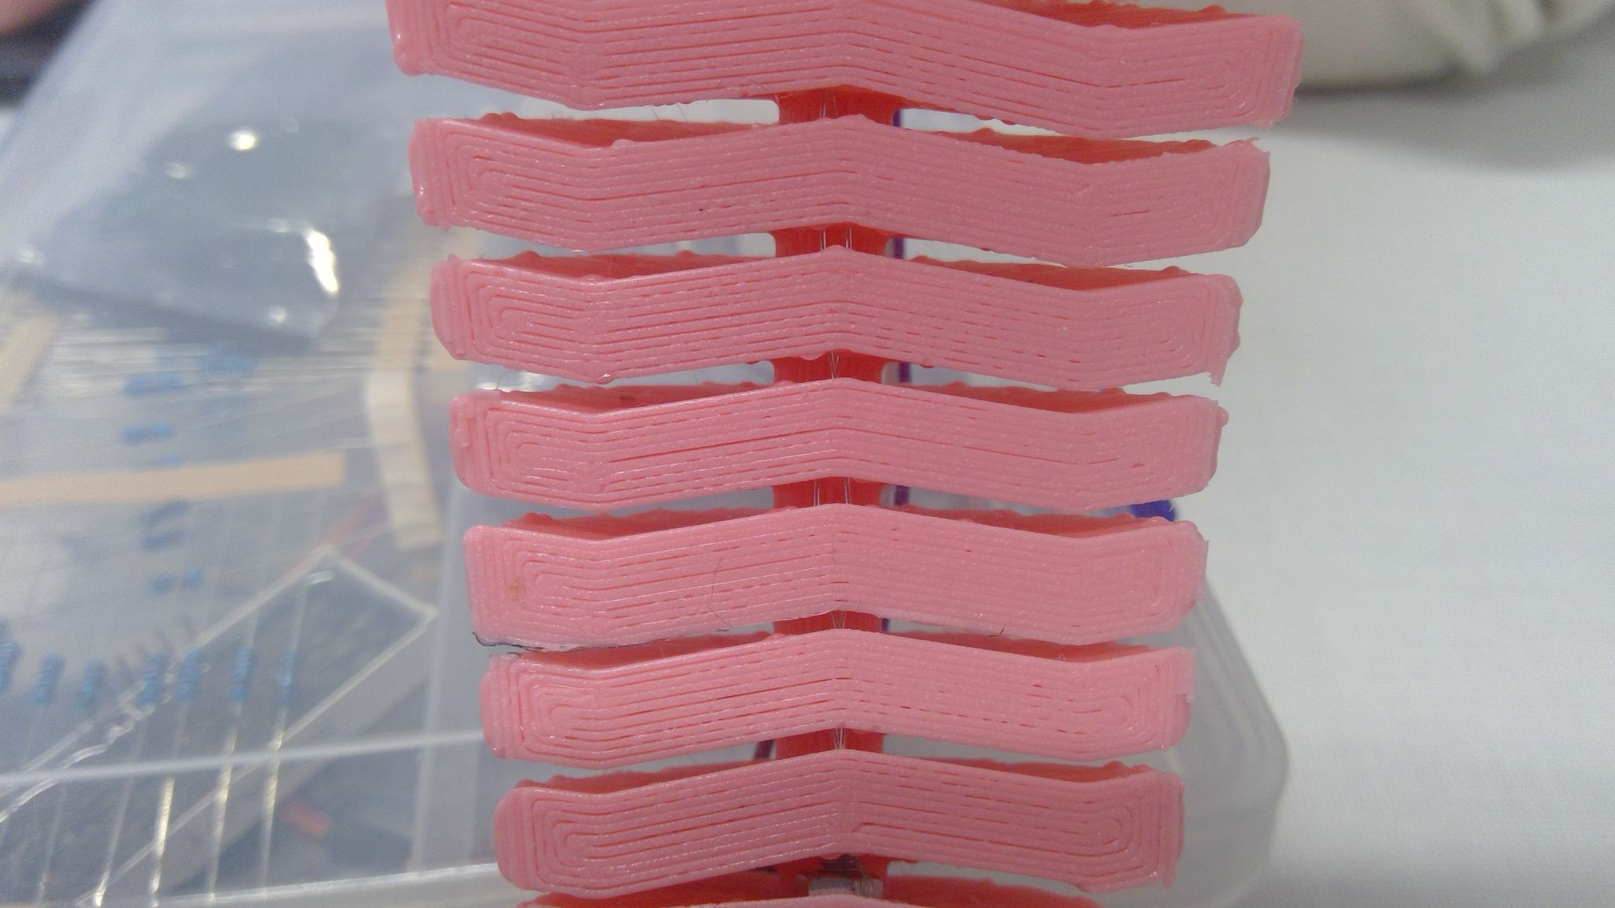
The design of the flexible pieces tile together. This achieves extra rigidity in the horizontal plane while the arm is under compression, as the scales of the arm are unable to slide past one another.

We could have had each scale attached to a horizontal, rectangular connection point, but that would have only allowed for vertical movement. The option to allow side to side movement was desirable as a stretch goal by the team.

Results:
DEMO VIDEO LINK

The final result of the project was achieved through time-consuming trial and error testing. The code was revised, the tension of the wires moving the legs of the worm was changed, and the orientations of the components in the body were altered as well.

Ultimately, the worm accomplished its biomimetic goal of simulating the locomotion style of a worm. Essentially, the legs attached to either end of the solid body are pulled in towards the solid body, pointing their ends down. Each end is released at a slightly different time, ensuring that the body is pushed forward by the back end, exactly how organic worms move.

Below is the link to a video demonstrating the success of the design:
https://clipchamp.com/watch/BRLKYaAk7Hn

Discussion:
In the demonstration video, it is clear that the robot does accomplish its unique goal of moving as worms do. However, the main issue is the speed at which it locomotes. Clearly, the worm moves very slowly, though this is in line with organic worms and the speed at which they move. According to a study published in PubMed (https://pubmed.ncbi.nlm.nih.gov/18493300/), nematodes (species of worm) move within a range of speeds quantified as 15.9-250 um/sec. As their speed is measured in micrometers, it is evident that, while the robotic simulation of a worm moves slowly, it still moves faster than an organic worm by orders of magnitude.

Conclusion:
It may be hypothesized that the speed of our robot is due not to the specific implementation of our robot, but it may be an attribute of the kinematics of wave-like movement. Taking into account the scale of our robot, we may further miniaturize and compare speed at a more lifelike scale. Further research should be done to confirm or deny whether high velocity is simply not a quality of this type of movement. Further experiments can be conducted with higher torque servo motors since a higher angular velocity of the servo translates directly to a higher tangential velocity of the cable via a pulley. Different flexible materials can be experimented with to select the most appropriate balance of flexibility, rigidity and flexibility.

References:

[1] J. H. Lai, J. C. del Alamo, J. Rodríguez-Rodríguez, and J. C. Lasheras, “The mechanics of the adhesive locomotion of terrestrial gastropods,” The Journal of experimental biology, https://www.ncbi.nlm.nih.gov/pmc/articles/PMC6514465/ (accessed Dec. 7, 2023).
[2] S. Malvar, R. G. Gontijo, B. S. Carmo, and F. R. Cunha, “On the Kinematics-wave motion of living particles in suspension,” Biomicrofluidics, https://www.ncbi.nlm.nih.gov/pmc/articles/PMC5554071/ (accessed Dec. 7, 2023).
[3]Ramot D;Johnson BE;Berry TL;Carnell L;Goodman MB;, “The Parallel Worm Tracker: A platform for measuring average speed and drug-induced paralysis in nematodes,” PloS one, https://pubmed.ncbi.nlm.nih.gov/18493300/ (accessed Dec. 7, 2023).

